Purpose
This pamphlet explains how personal information about you and your health is recorded and managed in our practice. We also have a written privacy policy describing how we manage personal information. You can receive a copy of our policy free of charge upon request or access it via our practice website.

Personal information
The ‘personal information’ we collect includes your name, date of birth, address/es, contact details, Medicare number, healthcare identifiers and health fund details. Medical information may include medical history and any care you may need. GPs need information about your past and present health in order to provide you with high-quality care.

Our practice follows the guidelines of the RACGP’s Privacy and managing health information in general practice resource. The resource incorporates federal and state privacy legislation, and the Australian Privacy Principles, which requires that your personal information is kept private and secure.

Your medical records
This practice takes steps to ensure that your medical records:
- are accurate, complete, well-organised and legible
- are up-to-date
- contain enough information to allow another GP to care for you
- contain a summary of your care
- can be used to remind you, with your permission, to return for follow up, check-ups and reviews.

If you are uncertain why information is being requested, please ask your GP or the practice staff.

If you wish to remain anonymous while accessing healthcare services, please talk to the practice staff.

Providing your information to other GPs
In this practice, it is normal for all GPs to have access to your medical records. If you have any concerns about this please discuss them with your GP or practice staff.

It is important that other people involved in your care, such as medical specialists and other healthcare professionals, are informed of the relevant parts of your medical history, so they can provide the best care for you. Your GP will let you know when this is necessary.

Providing your information to others
GPs respect your right to decide how your personal information is used or shared. For example, this may be sharing your health information with specialist doctors. Personal information that identifies you will only be sent to other people with your consent, unless there are exceptional circumstances. Gaining your consent is the guiding principle used by this practice in using and sharing your information.

Our practice will not share your personal health information with anyone else or another organisation unless:
- you have consented to this sharing, or
- they are legally obliged to disclose the information, in which case your GP will first discuss with you the information that she or he is legally obliged to disclose, or
- the information is necessary for you to obtain Medicare payments or other health insurance rebates, or
- there is an overriding public health and safety interest in the release of the information.

In the above cases, only information necessary to meet the requirements will be provided. Your health information will not ordinarily be sent overseas unless:
- you are informed and provide consent for this to occur, and
- the overseas country receiving the information has privacy laws that are very similar to the Australian Privacy Principles.

Using health information for quality improvement and research
This practice may use patient health information to assist in improving the quality of care we give to all our patients, by reviewing the treatments used in the practice.

Your information held by the practice may be used in research projects to improve healthcare in the community; however, this information will not include data that can identify you.

The information used for research, including the publication of research results, will not be in a form that would allow you to be identified, unless the research serves an important public interest. In such cases, identifiable medical records can be used for medical research without your consent under guidelines issued by the Australian Government. Before providing such identified information, your GP will discuss with you the information that she or he is obliged to disclose.

Security of information in the practice
Australian privacy legislation applies to all personal health information recorded in electronic and paper records. All records must be kept secure to protect against unauthorised access. This practice complies with these requirements to protect your information.

Access to your health information
You may ask practice staff about any aspect of your healthcare, including information contained in your record. You can request access to your medical record and any other information the practice records about you.

If you request access to your medical record, your GP will need to consider if there may be a risk of physical or mental harm to you or any other person that may result from disclosure of your health information. Your GP may need to remove any information that will affect the privacy of other individuals.

Sharing information is important for good communication between you and practice staff. Your GP is able to provide a full explanation of the health summary or medical record you are provided access to.

Depending on what is involved, you may be asked to contribute to the cost of providing the information.

Direct marketing
This practice does not engage in direct marketing.

Resolving concerns regarding the privacy of your health information
If you have any concerns regarding the privacy of your personal health information or the accuracy of the information held by the practice, you should discuss these with practice staff. Inaccurate information can be corrected or your concerns noted in your record. For legal reasons, the original notes will be retained.

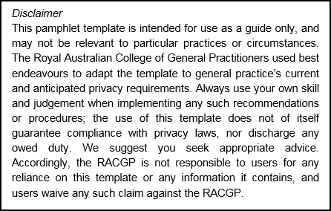
Contacts
If you have questions or a complaint about the privacy of your personal information, please ask to speak to the privacy contact officer at the practice.
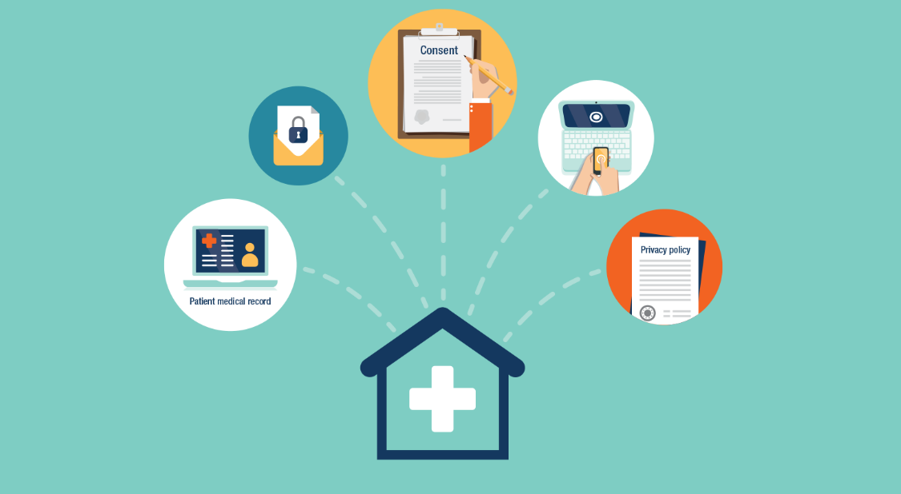

Keeping your personal information private in our practice

Parkes Street General Practice
129 Parkes Street
Helensburgh NSW 2508
Phone:(02) 4294 1400
Fax:(02) 4294 1082
website: www.psgp.com.au

Further information on privacy legislation is available from:

Office of the Australian Information Commissioner
1300 363 992
www.oaic.gov.au

ACT Health Services Commissioner
02 6205 2222
www.hrc.act.gov.au/health

Health and Disability Services Complaints Office
Western Australia – 1800 813 583
www.hadsco.wa.gov.au/home/index.cfm

Information and Privacy Commission
New South Wales – 1800 472 679
www.ipc.nsw.gov.au/privacy/ipc_index.html

Office of the Health Services Commissioner
Victoria – 1300 582 113
www.health.vic.gov.au/hsc/index.htm

Office of the Information Commissioner
Northern Territory – 1800 005 610
https://infocomm.nt.gov.au

Office of the Information Commissioner
Queensland – 07 3234 7373
www.oic.qld.gov.au

Ombudsman Tasmania
1800 001 170
www.ombudsman.tas.gov.au

Health and Community Services Complaints Commissioner (HCSCC)
South Australia – 08 8226 8666
www.hcscc.sa.gov.au

Parkes Street General Practice
129 Parkes Street
Helensburgh NSW 2508
Phone:(02) 4294 1400
Fax:(02) 4294 1082
website: www.psgp.com.au

